1. **What is LMS?**

A **learning management system** (**LMS**) is a software application for the administration, documentation, tracking, reporting, and delivery of educational courses, training programs, or learning and development programs.[[1]](https://en.wikipedia.org/wiki/Learning_management_system#cite_note-ellis-1) The learning management system concept emerged directly from e-Learning. Although the first LMS appeared in the higher education sector, the majority of the LMSs today focus on the corporate market. Learning Management Systems make up the largest segment of the learning system market. The first introduction of the LMS was in the late 1990s.

1. **Has any Learning management system been Deployed for FPNO?**

Yes, **Moodle** has been deployed for the Purpose of or e-Learning/Virtual/Distance learning for staff and students of the Institution.

1. **What is Moodle LMS?**

**Moodle** is an acronym for "Modular Object-Oriented Dynamic Learning Environment." It is an online educational platform that provides custom learning environments for students. Educators can use **Moodle** to create lessons, manage courses, and interact with teachers and students. It is one of the world’s most popular Learning Management System (LMS).

1. **What is the Difference between Moodle LMS & Blackboard?**

**Moodle**: **Moodle** is an open-source learning management platform designed to help schools educate their students. ... **Blackboard**: **Blackboard** Learn is a web-based LMS that's used in both academic and business environments to help students and employees improve their learning experience.

1. **Which is better Moodle or Blackboard?**

**Moodle** has a well-designed architecture, so it’s faster as compared to **Blackboard**, where students have faced problems while loading pages. **Moodle** does not allow you as a student to work offline but **Blackboard** lets you complete your courses and activities offline.

1. **How can one Access FPNO (Moodle) LMS**

To gain access to FPNO LMS By Visiting <https://moodle.fpno.edu.ng/> but only staff assigned to courses in a department and students who have paid their school fee have access to Login.

1. **What are the features of FPNO LMS(Moodle) for a Lecturer?**
2. Modern, easy to use interface. ...
3. Personalised Dashboard. ...
4. Collaborative tools and activities. ...
5. All-in-one calendar. ...
6. Convenient file management. ...
7. Simple and intuitive text editor. ...
8. Notifications. ...
9. Track progress.
10. Chat
11. Assignments
12. Upload Resources such as Video tutorials, course , etc
13. **What are the Activities a Lecturer can perform in FPNO LMS?**

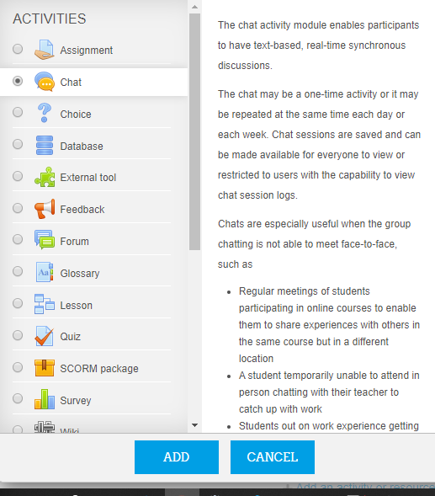

1. **Steps of how a lecturer can perform a course management activity?**
2. **Visit** <https://moodle.fpno.edu.ng/>
3. **Click on Login at the Top Right Corner**
4. **Enter your email and password. The default password is fPNO@123**
5. **Once you successfully login you will be a Redirected to your dashboard. You will see a list of courses assigned to you.**
6. **Click on any of the Course to Add Details**
7. **To Create Announcement, Click on (Create New Topic)**
8. **To Create an Activity (Assignment, Lecture Note Uploads, set quiz etc)**

To create an activity Click on Turn Editing On the Course DashBoard.

We will now have an Edit Mode Screen.

Click on Add an Activity for any week dates as shown below

The following are the list of Activities that can be performed

To create a new Lesson for that course, select **Lesson**

**Then click on Add**

1. **Enter The name of the Lesson and Description**
2. **Set other Options and click on Save and Return**